**Student Names:**  Nathan Long and Brice Martinelli

**Project Instructions: Submit your project by 11:59 p.m. ET on Thursday, April 20th via Canvas.  
Include this file with answers provided for each question, your completed Microsoft Excel file   
BIZ-JET-PROJECT, the three-view drawing of your business jet design, and your marketing brochure.**

**Part I: Understanding the Problem**

**History**

Over the past forty years business jets have become a very popular way to travel, including corporate trips, charter flights, and wealthy individuals’ vacations. Reasons for its popularity are greater ease of travel, ease of access, hassle-free transit with high comfort levels, and direct routes.

Many major aerospace companies have designed, built, and sold business jets – including Beechcraft, Bombardier, Cessna, Dassault, Embraer, Gulfstream, and Learjet. There are presently over 21,000 business jets used all over the world, ranging in cost from $2M to over $70M each.

**Setting the Requirements**

By doing some research on the variety of business jets that Cessna, Gulfstream, and Learjet have designed over the past forty years, the aircraft designer can readily assess any market opportunities for a new design that would fill the needs for corporate or individual travel.

On the next two pages there are three charts that show the historical data for Maximum Range, Seat Miles, and Payload vs Maximum Takeoff Gross Weight for 23 different business jets built by those three companies. **There seems to be a gap in the data between 40,000 and 70,000 pounds where there are no aircraft depicted. Your company believes that this could be the design space for a new business jet design.**  Given this opportunity to design a business jet in this weight range, what would your requirements be for this size of aircraft? By drawing a linear trendline through all of the data on each chart the aircraft designer could come up with some achievable requirement options for the Maximum Range, Seat Miles, and Payload parameters (assume 200 lb / passenger).

1. **Insert your best guess for a linear trendline through the data on each of these three charts.**
2. **What is your range requirement for this new design? 4,500 NM**
3. **How many passengers will this new business jet carry? 14 passengers**
4. **What is your first guess for Takeoff Gross Weight? 60,000 lb**
5. **Annotate these design requirement choices on the three charts by inserting a symbol.**
6. **Do you think that these requirements are achievable? Yes No  
   Please explain your answer.**  There are many jets which are only slightly heavier than ours on the plots and the only main difference is that they have a shorter range in exchange for more passengers. Using a similar design to theirs, we should be able to carry fewer passengers in order to increase our range, meeting our design requirements.

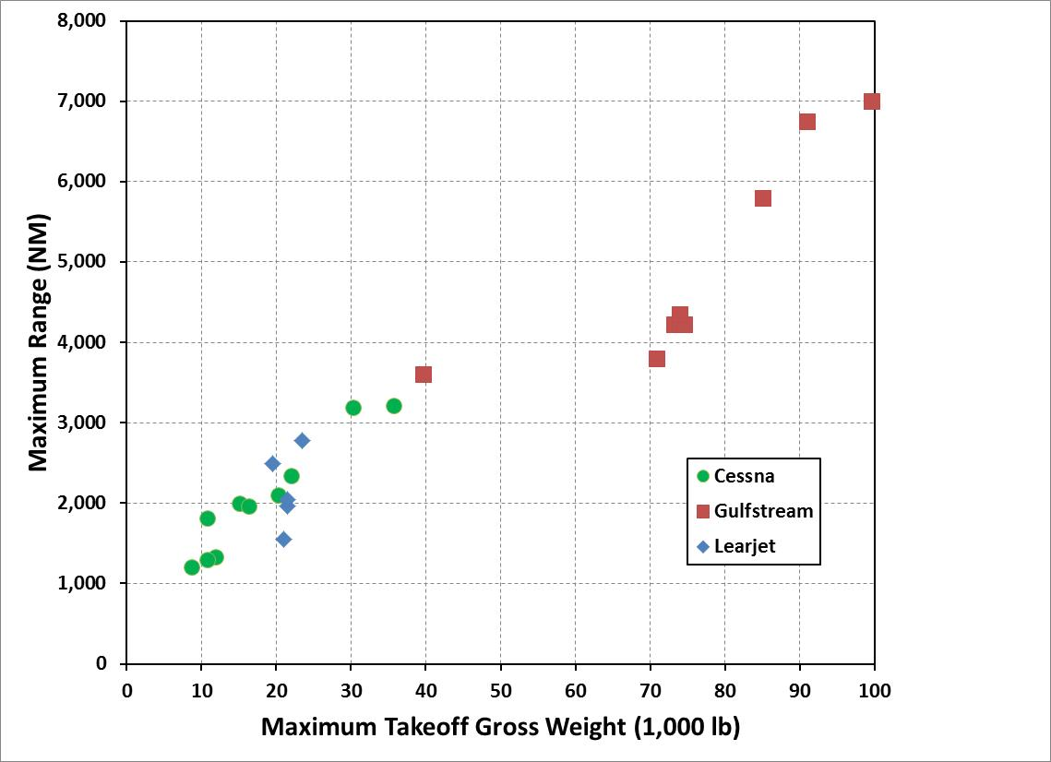

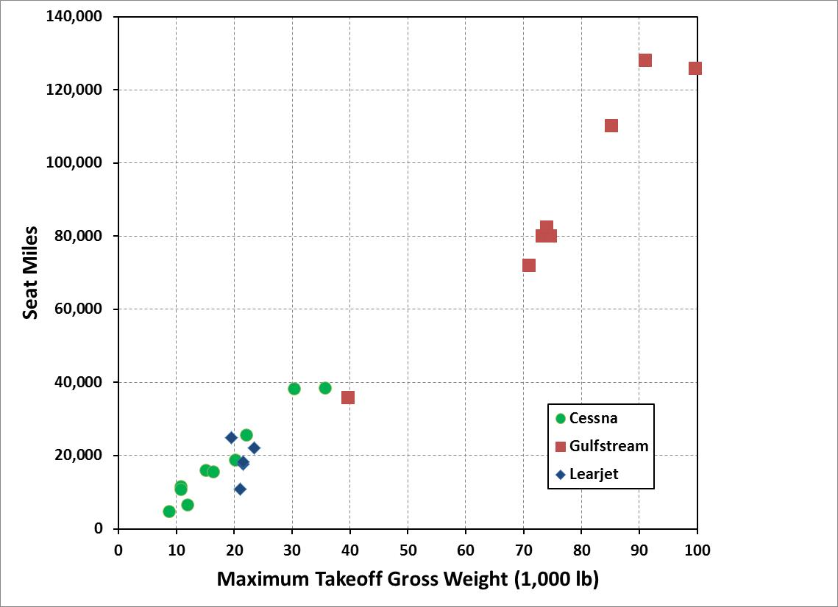

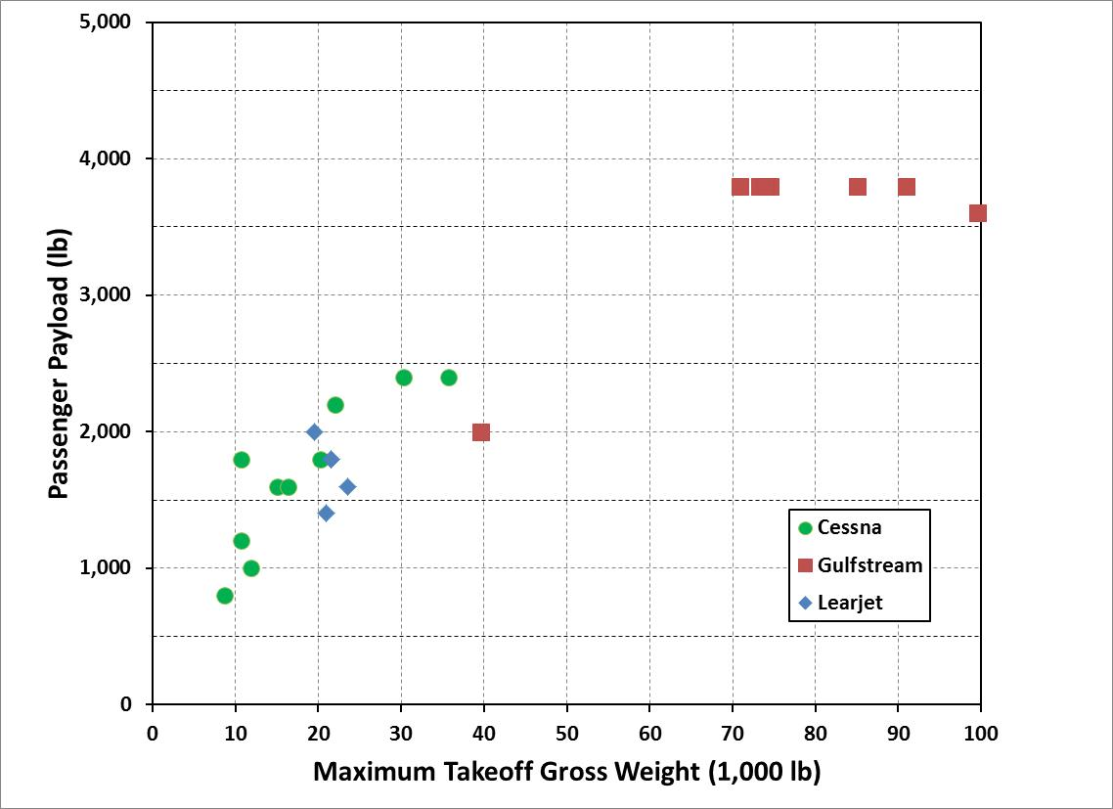

1. **Provide your rationale for picking values for the following parameters:**  
     
   Range (NM) We did not want a super large aircraft but rather one that was closer to the middle of the weight range. Because of this, we decided to pick a range of 4,500 NM as it was a whole number and allowed our TOGW to be 60,000 lbs.

Number of passengers Our weight was chosen to be 60,000 lbs and based on the line we created, the passenger payload was around 2,800 lbs and at 200 lbs per person, we calculated that we could carry 14 people.

**Part II: Initially Sizing the Aircraft**

1. **Using the historical charts on this page, pick values for the following parameters:**Cruise Mach number = **0.75M** Aspect Ratio = **7.8**  
   Structure Factor (Operating Weight Empty / Maximum Takeoff Gross Weight) = 0.56  
   Thrust (lb) – number of engines x thrust/engine = **21,900**  
    (determine a reasonable T/W and multiply by Takeoff Gross Weight)
2. **Input these requirements into the ITERTOW-BIZ spreadsheet in the gray-shaded cells:**Range (NM) Payload (lb) = number of passengers x 200 lb (no additional cargo)
3. **Input these other parameters into the ITERTOW-BIZ spreadsheet in the gray-shaded cells:**Optimum altitude (ft) – typically 36,000 ft for turbofan engines  
   Fuel Reserves: 45 minutes at 10,000 ft + 5% fuel reserves + 1% trapped fuel  
   Maximum Mach number (cruise Mach number plus some delta Mach: +0.05 is sufficient)
4. **Iterate on TSFC to get the spreadsheet-calculated Takeoff Weight very close to your first-guess Maximum Takeoff Gross Weight that you chose in Part I.**  TSFC = **0.6151**
5. **Insert a symbol to annotate your design parameter choices on the appropriate charts below.**

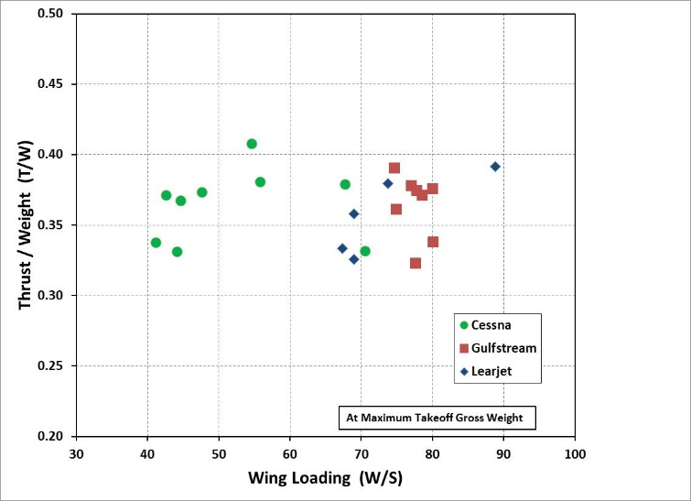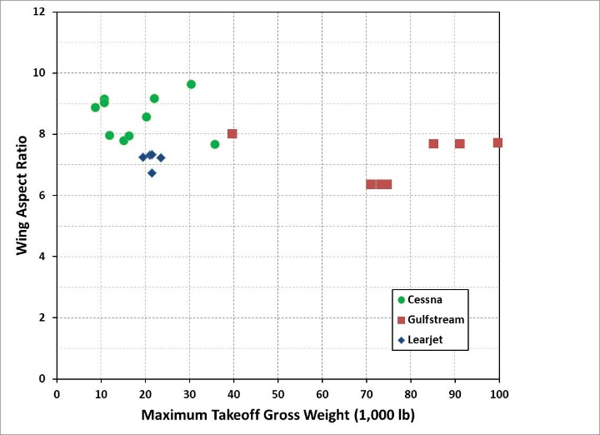

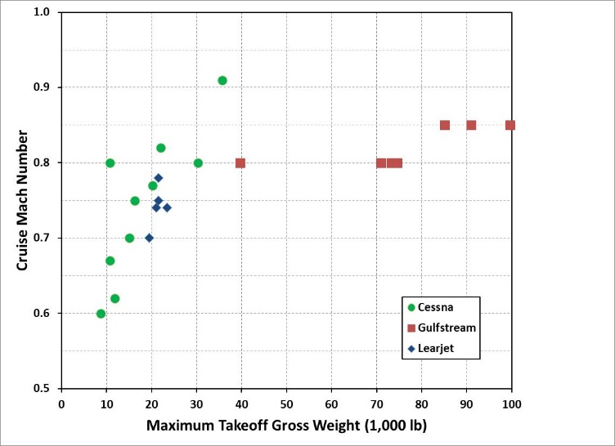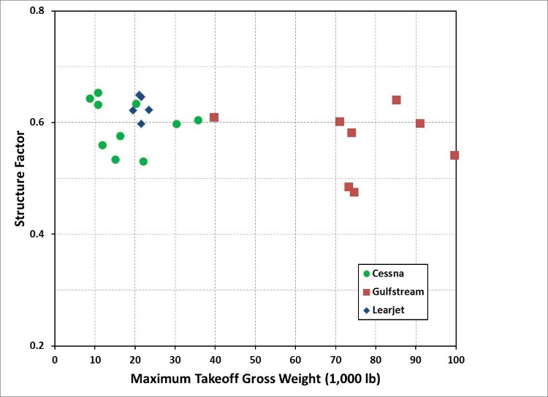

1. **Provide your rationale for picking values for the following parameters:**  
   Cruise Mach number In order to ease our decision making responsibility, we created linear best-fit lines and used the lines at our max TOGW in order to determine the cruise Mach number. We originally got a Mach close to 0.9, and upon further consideration decided to move our line down in order to get a lower cruise Mach in order to not deal with sonic flow conditions.  
     
     
     
     
     
   Aspect Ratio Similarly to the cruise Mach number, we simply eye-balled a line that seems to fit the data and chose the Aspect Ratio that is located at the intersection of that line and our max TOGW.  
     
     
     
     
     
   Structure Factor We followed the same rationale for picking the structure factor as the other parameters, by picking a line that looked reasonable and then picking the structure factor that was located at the intersection of the line and 60,000 lbs.  
     
     
     
     
     
   Thrust (lb) For T/W, we picked a line that was roughly in the center of all the data points and used the value that the line fell on. We then used this value to calculate the Thrust by multiplying T/W and TOGW.
2. **Use your ITERTOW Excel spreadsheet to examine the sensitivity of your selected Maximum Range and Payload (Number of Passengers) to answer these two scenarios:  
     
   A. A corporate customer is very interested in buying one of your business jets but they require that its Maximum Range be increased by 200 NM. The customer would like to know how much this requirement would increase the Takeoff Gross Weight (TOGW) and Operating Weight (OW) of the aircraft and what the differential cost of the aircraft would be.  
    (assume D Cost ($) = 670 * DTOGW)**

**B. The corporate customer would also like to know the aircraft’s differential cost of an aircraft in Scenario A but with a Payload capacity with two less passengers.**

|  |  |  |  |  |  |
| --- | --- | --- | --- | --- | --- |
|  | **D Max Range** | **D Payload** | **D TOGW** | **D OW** | **D Cost** |
|  | **(NM)** | **(lb)** | **(lb)** | **(lb)** | **($)** |
| **Original Design** | 4,500 | 2,800 | 60,000 | 33,600 | 40,200,000 |
| **Scenario A** | + 200 | 0 | 17,389 | 9,738 | 11,650,630 |
| **Scenario B** | + 200 | - 400 | 6,334 | 3,547 | 4,243,780 |

**Part III – Refining the Design**

1. **Given the results of the analysis done in the ITERTOW-BIZ spreadsheet, input those parameters and these new parameters into the WINGLOAD-BIZ spreadsheet in the gray-shaded cells:**Takeoff CLmax = **2.08** (the chart below has data for your company’s proprietary   
   Landing CLmax = **2.40** takeoff & landing flap configurations for this type of aircraft)CD0 = **0.0156** (use Cfe = 0.0030 and Swet/Sref = 5.0 – 5.4 : lower than the airliner data)

Wing Area (ft2) = **857** (determined from the T/W vs W/S chart and Maximum TOGW) (W/S=70)

1. **Iterate on Cruise Start Altitude to find where Lift = Weight – this is the cruise leg’s initial altitude. Then iterate on the Cruise End Altitude to find where Lift = Weight – this is the cruise leg’s final altitude, given a constant Mach Number cruise climb.**
2. **Annotate your design parameter choices for T/W and W/S on the T/W vs W/S chart on page 4.**
3. **Provide your rationale for picking values for the following parameters:**  
   Takeoff CLmax We picked a takeoff CLmax associated with the leading edge sweep that corresponded to our cruise Mach number of 0.75. This gave us a CLmax of 2.08.  
     
     
   Landing CLmax Similar to the takeoff maximum lift coefficient, we chose a landing CLmax that occurred at the same leading edge sweep (20.5°) as the cruise Mach, giving us a value of 2.40.  
     
     
   Wing Area Since most of our other parameters were located close to the gulfstream data clusters, we picked a W/S that was a similar distance from the cluster as the other parameters. We then divided our original max TOGW of 60,000lbs by 70 W/S to get 857.14 ft^2.  
     
     
     
   CD0 We picked an Swet/Sref of 5.2 since it was in the middle of the range we were given, and using a Cfe of 0.0030, e calculated the CD0 to be 0.0156.

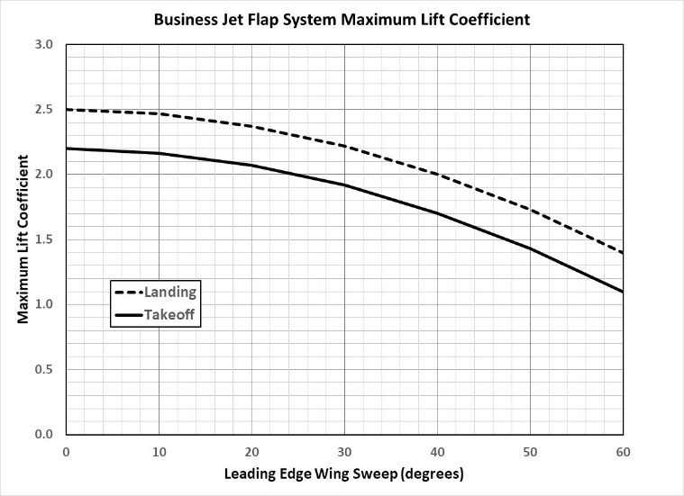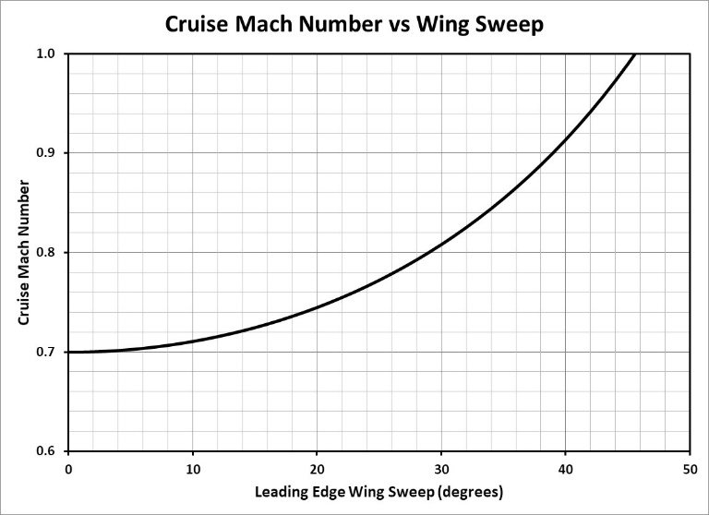

0.75

**Part IV – The Rest of the Initial Design Details**

1. **Given the results of the analyses done in the ITERTOW-BIZ and WINGLOAD-BIZ spreadsheets, input those parameters and these new parameters into the WING-BIZ spreadsheet in the gray-shaded cells:**  
   Leading Edge Sweep (deg) = **20.5**   
      
   Wing Taper Ratio = **0.38** (0.3 to 0.4; 0.35 is a good approximation for an elliptical wing)  
   The rest of the inputs are automatically referenced in from the other spreadsheets  
     
   **The wing’s half-planform is drawn out in the Wing Plan View tab in the workbook.**
2. **At the end of this analysis you should have determined many important design parameters for your business jet. Fill out this table with all of these values:**

|  |  |  |
| --- | --- | --- |
|  | **Units** | **Value** |
| **REQUIREMENTS** |  |  |
| Range | NM | 4,500 |
| Number of Passengers | # | 14 |
| Passenger Payload | lb | 2,800 |
| **PERFORMANCE CAPABILITIES** |  |  |
| Takeoff Distance: 100% fuel @ SL | ft | 2,432 |
| Landing Distance: 20% fuel @ SL | ft | 2,620 |
| Cruise Altitude & Speed | ft / Mach | 34,908 / 0.75M |
| **AIRCRAFT WEIGHTS** |  |  |
| Takeoff Gross Weight | lb | 60,000 |
| Fuel Capacity | lb | 23,600 |
| Operating Weight Empty | lb | 33,600 |
| Structure Factor | -- | 0.56 |
| **PROPULSION** |  |  |
| Maximum Thrust | lb | 21,900 |
| Cruise TSFC | lb/lb-hr | 0.6151 |
| **WING** |  |  |
| Wing Area | ft2 | 857.0 |
| Wing Span | ft | 81.8 |
| Aspect Ratio | -- | 7.8 |
| Root Chord & Tip Chord | ft | 15.2 & 5.8 |
| Taper Ratio | -- | 0.38 |
| Leading & Trailing Edge Sweeps | degrees | 20.5 & 8.2 |
| M.A.C. length & yMAC location | ft | 11.2 & 17.38 |
| **FUNDAMENTAL PARAMETERS** |  |  |
| Takeoff T/W | -- | 0.6350 |
| Takeoff W/S | lb/ft2 | 70.01 |

1. **Provide your rationale for picking values for the following parameters:**  
   Leading Edge Sweep (deg) We used our value for the cruise Mach number on the cruise Mach number versus wing sweep chart in order to determine our leading edge sweep angle.  
     
     
   Wing Taper Ratio We felt that a higher wing taper ratio looked more appealing in the wing plan view but did not want to push too close to the maximum in the recommended range.

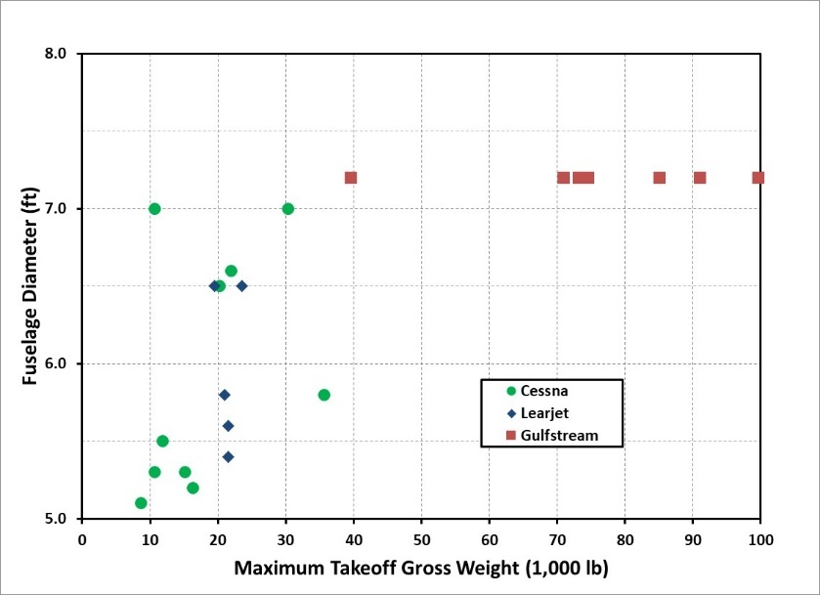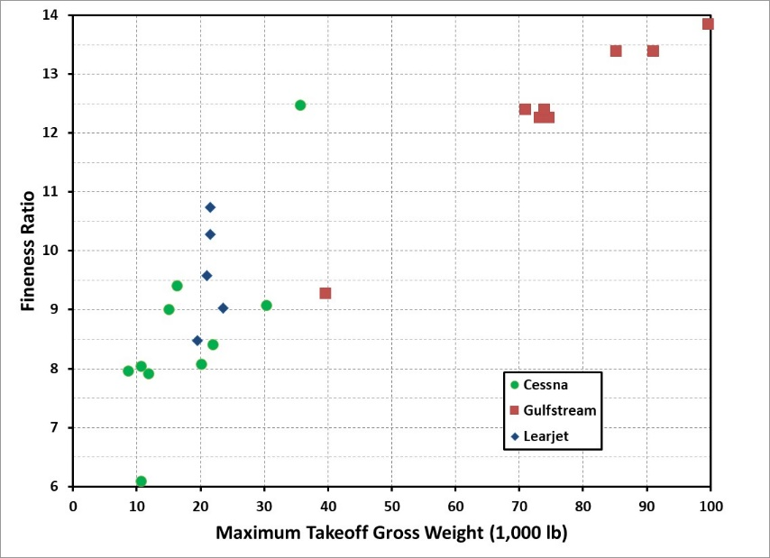

1. **Fuselage Design - Using the historical charts above, pick values for the following parameters:**  
   Fuselage Diameter (ft) = 7.2 Fineness Ratio = **11.80**

**Annotate your fuselage design choices on the charts above. Provide your rationale for picking the values for these parameters:** For fuselage diameter, all fuselages for MTGW’s above 40,000lbs have a diameter of 7.2ft so we figured it would be appropriate to do the same. For fineness ratio, we approximated a linear curve fit and chose the value corresponding to our MTGW.

1. **Input these requirements into the FUSELAGE-BIZ spreadsheet in the gray-shaded cells.**Pick values for the fuselage parameters lc-nose / L and lc–tail / L to tailor the fuselage shape.

lc-nose / L = 0.17

lc–tail / L = 0.20

1. **Tail Design – Using the included business jet guidelines, input values for the following parameters into the TAIL-BIZ spreadsheet in the gray-shaded cells:**  
   Vertical Tail Volume Coefficient (CVT) **0.075** (0.05 to 0.10)  
   Vertical Tail Length Percentage (ltail / lfuse %) **45.0%** (40% to 50%)  
   Vertical Tail Taper Ratio (VT) **0.80** (0.6 to 1.0)  
   Vertical Tail Aspect Ratio (ARVT) **0.95** (0.7 to 1.2)  
   Vertical Tail Leading Edge Sweep (☹LE) **28.5** (VT ☹LE = Wing ☹LE + 8 deg;  
    or 35 to 50 deg)  
   Horizontal Tail Volume Coefficient (CHT) **0.85** (0.5 to 1.2)  
   Horizontal Tail Length Percentage (ltail / lfuse %) **50.0%** (40% to 50%)  
   Horizontal Tail Taper Ratio (HT) **0.45** (0.3 to 0.6)  
   Horizontal Tail Aspect Ratio (ARHT) **4.00** (3 to 5)  
   Horizontal Tail Leading Edge Sweep (☹LE) **25.5** (HT ☹LE = Wing ☹LE + 5 deg)
2. **At the end of these analyses you should have determined many more important design parameters for your business jet. Fill out this table with all of these values:**

|  |  |  |  |  |  |
| --- | --- | --- | --- | --- | --- |
| **TAIL DESIGN** |  | **Units** | **Horizontal Tail** | **Vertical Tail** | **Main Wing** |
| Leading Edge Sweep Angle | ☹LE | degrees | **25.5** | **28.5** | **20.50** |
| Trailing Edge Sweep Angle | ☹E | degrees | **5.6** | **17.2** | **8.2** |
| Quarter-Chord Sweep Angle | ☹c/4 | degrees | **20.9** | **25.8** | **17.6** |
| Root Chord | cr | ft | **10.07** | **13.37** | **15.2** |
| Tip Chord | ct | ft | **4.53** | **10.69** | **5.8** |
| Span | b | ft | **29.20** | **X** | **81.8** |
| Height | h | ft | **X** | **11.43** | **X** |
| Taper Ratio | ● | -- | **0.450** | **0.80** | **0.380** |
| Surface Area | S | ft2 | **213.2** | **137.5** | **857.0** |
| Aspect Ratio | AR | -- | **4.00** | **0.95** | **7.80** |
| MAC length | MAC | ft | **7.65** | **12.08** | **11.2** |
| yMAC location | yMAC | ft | **6.38** | **5.50** | **17.38** |
| Distance from tail’s c/4 of MAC  to wing’s c/4 of MAC | lHT | ft | **38.2** | **X** | **X** |
| Distance from tail’s c/4 of MAC  to wing’s c/4 of MAC | lVT | ft | **X** | **38.23** | **X** |
| Horizontal Tail Volume Coefficient | CHT | -- | **0.85** | **X** | **X** |
| Vertical Tail Volume Coefficient | CVT | -- | **X** | **0.075** | **X** |
| **FUSELAGE DESIGN** |  | **Units** | **Value** |  |  |
| Fineness Ratio | L/D | -- | **11.80** | **X** | **X** |
| Fuselage Length | L | ft | **84.96** | **X** | **X** |
| Fuselage Diameter | D | ft | **7.20** | **X** | **X** |

**Part V – Business Jet Design Project’s Second Iteration**

|  |  |  |  |
| --- | --- | --- | --- |
| **AIRCRAFT WEIGHTS** | **Units** | **First Guess Value** | **Updated Value** |
| Operating Weight | lb | 33,600 | 34,529 |
| Payload | lb | 2,800 | 2,800 |
| Fuel Capacity | lb | 23,600 | 23,600 |
| Takeoff Gross Weight | lb | 60,000 | 60,929 |
| **AERODYNAMICS** |  |  |  |
| Swet/Sref | -- | 5.2 | 4.98 |
| CD0 | -- | 0.0156 | 0.0194 |

1. **Fill out this table with your first guess values and the updated values from ITERATION2-BIZ:**
2. **How well do these first guess and updated values compare? Why?**The first guesses were very close to the updated values as our TOGW only increased by about 1,000 lbs. We expected our takeoff weight to increase significantly more than it did, additionally, our drag polar is larger which is expected as it is calculated from the aircraft geometry rather than approximation. Though it is odd that CD0 increased so much while at the same time the Swet/Sref decreased.

1. **If you were to go through a second iteration of the design process, what changes would you make to your aircraft configuration? Would you make these changes to improve the performance of the aircraft or for some other reason? Why?**First of all, we would likely reduce our jet’s range. With our ideas for the plane interior, we would like to carry more passengers at our current weight, and by reducing the range we could afford to carry less fuel. We would also likely reduce the length of the nose and tail relative to the length of the fuselage in order to give the interior of the plane more room for amenities. We would also increase ltail / lfuse % for both tails as this both makes them look more appealing and reduces the overall drag caused by each tail.

**Part VI – Business Jet Design Project Conclusions**

1. **Using the drawn shapes in the “Wing Plan View”, “Fuselage Side View”, “Vertical Tail Side View”, and “Horizontal Tail Plan View” tabs, construct a three-view drawing of your business jet design with dimensions annotated for the wingspan, aircraft length, and aircraft height. Be sure to account for any scale differences in the various drawn figures as you construct this drawing. Your three-view drawing can be hand-drawn or constructed on the computer using those images. Be creative and add the cockpit and passenger windows, draw in where the engines and the door might be placed, and name your aircraft.**
2. **Prepare a draft one-page marketing brochure that highlights the features of your business jet design. Be sure to include an image of the aircraft, its dimensions, its performance capabilities (including takeoff & landing distances and range), and any unique characteristics that would interest any prospective buyers (no fish tanks and no hot tubs!). You can use this equation to determine what your business jet costs: Cost ($) = 670 * TOGW – 3,000,000 = $37.82 million**
3. **During the class lecture we discussed many of the desired attributes that a business jet may have or should have for the corporate or individual owner. Which of these attributes do you think are most important for a prospective buyer of a business jet?**

For typical buyers, comfort, various amenities, and range are important qualities of a business jet. Since the customers for these jets are wealthy, their time is worth a lot to them and hence do not want to waste time dealing with setting things up or “making do” with sup-par features. For instance, a built-in computer system that allows the user to project presentations is a great quality of business feature since it would allow them to work faster and with less stress. With features like these, regardless of speed, if a jet allows the consumer to work and live out their day-to-day life, it will make the consumer’s life easier as they don’t need to sacrifice their time to travel.

1. **What type of aircraft design assignment would you be most excited about? Why?  
   (each student on the project team should answer this question)**

**Nathan**: I would be most excited if we got to take a shot at an experimental aircraft design. I know most of the calculations would be difficult, but I feel like it would be fun to treat it like a Mr. Potato Head sort of design where you choose features from a list of presets and try and design a unique but functional aircraft. I think this would be fun because we could learn why planes are designed the way they are by choosing bad designs and failing to make a functional aircraft.

**Brice**: A project that involved us creating more tools to use for aircraft development and design would be nice. I felt like for this project we mainly just picked values that “looked” good and the excel sheet made the calculations for us. I think it could have been beneficial to be able to create performance approximations based on our design to see how the parameters we chose would affect how it flew. I plan on implementing what we learned (basically all of the excel sheet for this project) into Python that will allow me to create plane designs that can be altered relatively easily. As Nathan said, I also think it would be interesting to learn more about experimental aircraft designs and how design choices affects performance.

1. **Provide a brief description of how each student on this project team contributed to completing this aircraft design project:**

**Nathan Long**: ITEROW and FUSELAGE Excel sheets and the only other part of the project not jointly worked on was the first half of part 3. I did more of the table entries for the Word doc while Brice did more of the parameter explanations.

**Brice Martinelli**: Did a majority of parameter justifications in the Word doc and jointly worked on everything else besides the ITEROW and FUSELAGE Excel sheets.